**ANURAG GROUP OF INSTITUTIONS**

INTERNET OF THINGS PROJECT ON HEALTH MONITORING SYSTEM

TEAM NAME – THE HAT TRICKS

**BY:**

AITHAGANI SREYA – 19H61A04C2

GOLI SPANDANA REDDY – 19H61A04D7

DANDIBHOTLA KANTHISRI – 19H61A04H6

ABSTRACT:

Having a good health is really important for us. But because of the busy lives, people are ignoring their health. Because they don’t have much time to spare, they neglect their health and don’t go to the doctors. In this, we are going to create a webpage using node-red and try to send notifications to our mobile numbers about our health.

INTRODUCTION:

There are many health monitoring systems available in the market. They are in the form of wristbands or some sensors, ets. But sometimes, the person whose health is not good cannot be able to call their family members if he is living alone. In this project, we use an online simulator which notes the vitals of the person's body. The health tracking system is so built that it sends notifications to the registered users-say the guardian of the person- and if the vitals are in a dangerous state then the notifications about the vitals of the person are sent to both the guardians and their doctors.

OBJECTIVES:

* Easy to use
* Because we would get notifications as soon as there’s a change in the body vitals, we can concentrate more on our professional lives.

METHODOLOGY:

* First, cloud.ibm.com is to be opened and the user credentials are to be given. Then, we need to open the services and the registered iot platform in it.

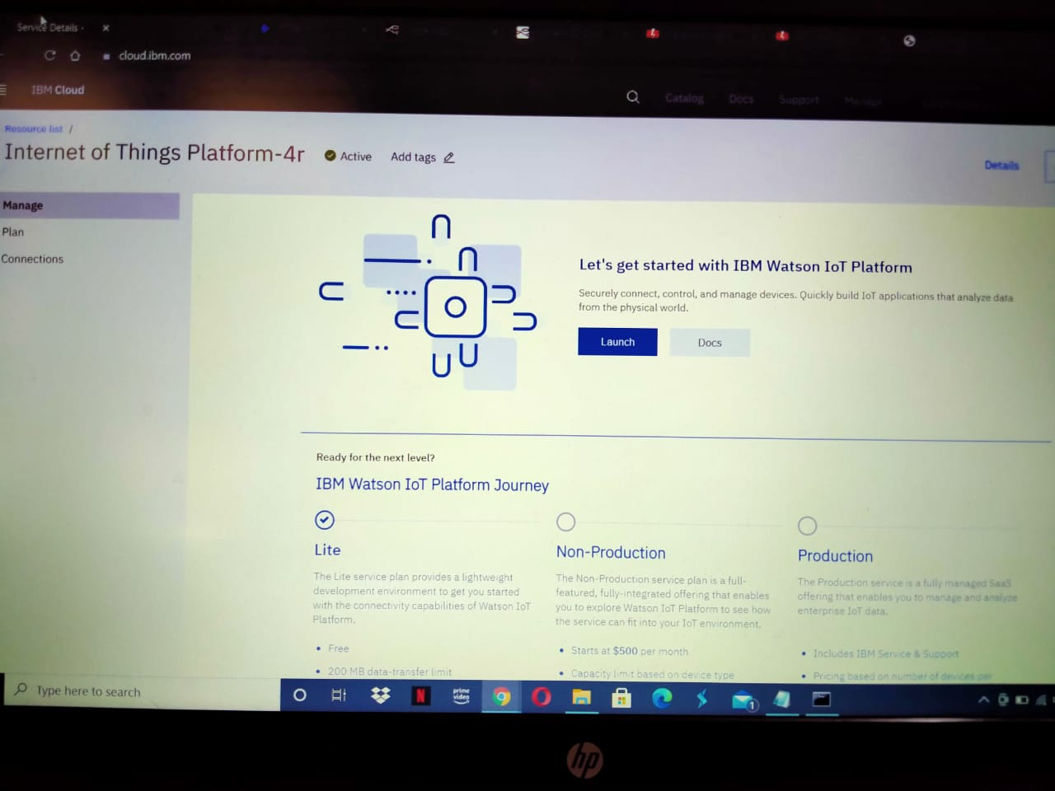

* Now, launch the platform. Then we’d be directed to another page and after entering the user credentials there again, and selecting the default organization, we’d be directed to the below page.

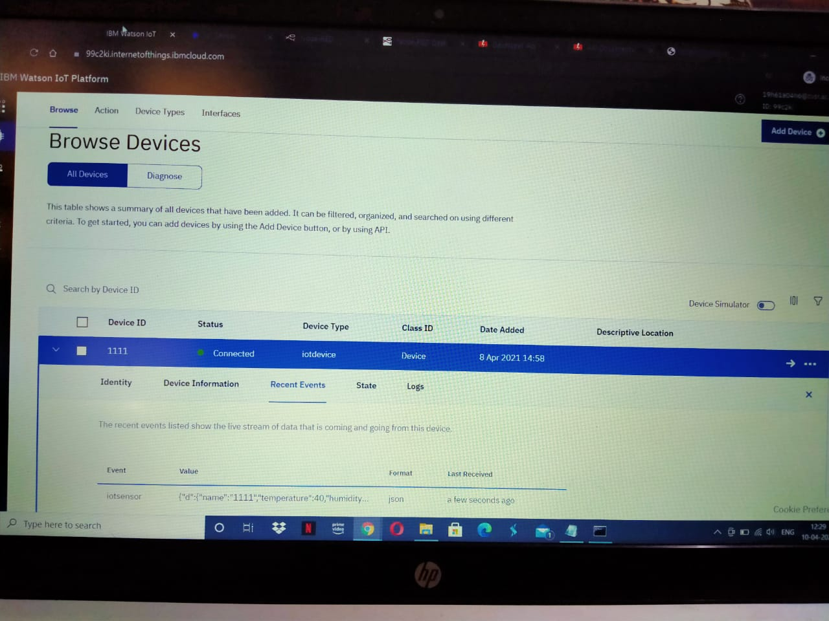

* Now open Watson iot sensor simulator and use that to change the temperature, humidity or object temperature.

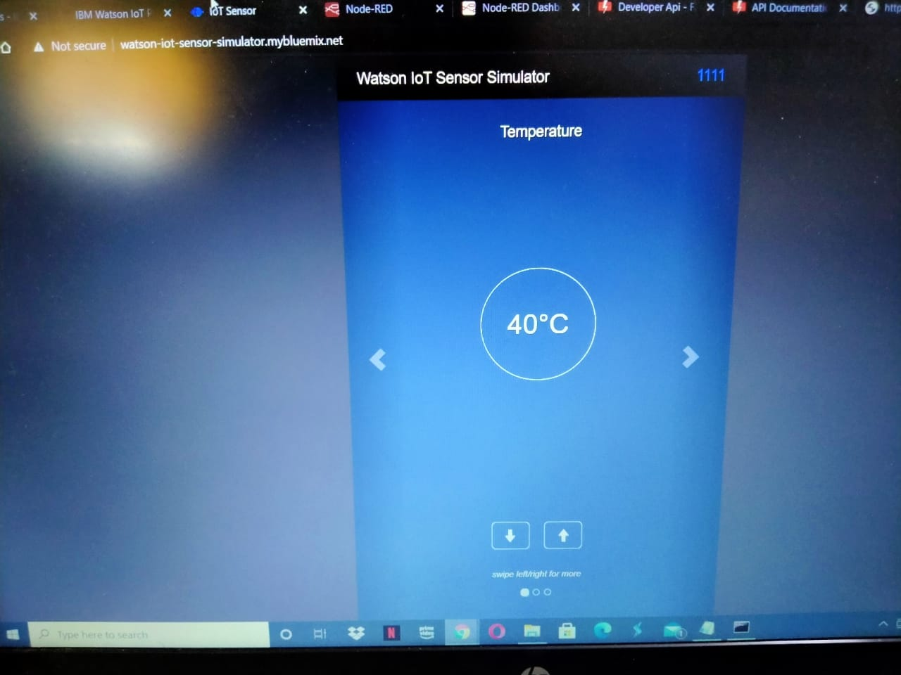

* Now in the command prompt, use the command ‘node-red’ and when pressed enter, a command called ‘Server now running’ comes.

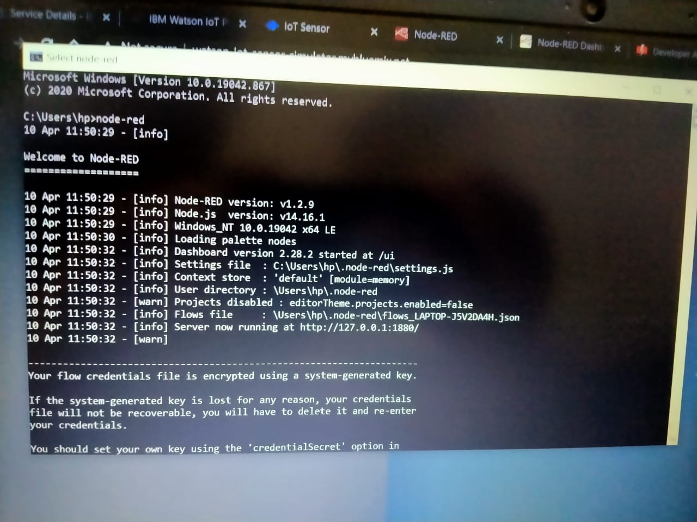

* Use that http url to open the nodered page. Now use the different nodes present in it and create the connections such that we’d get notifications to the registered mobile number.

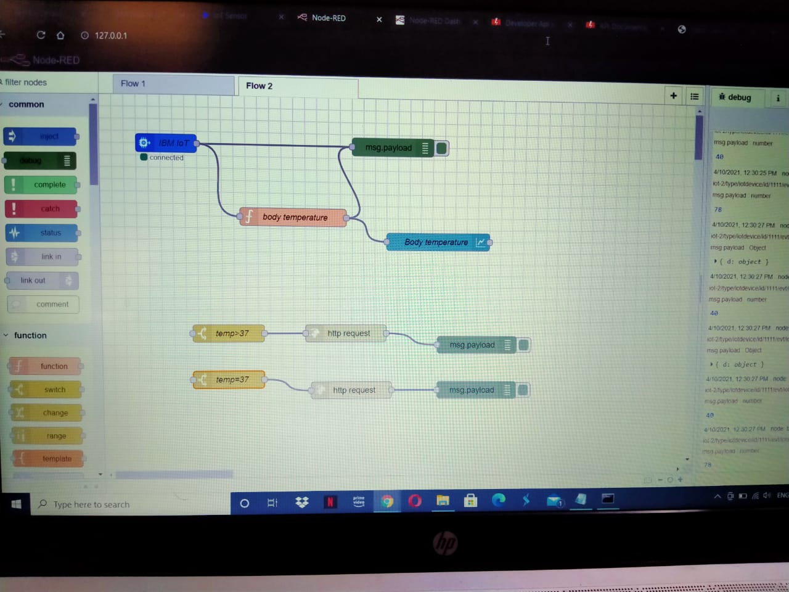

* Here, we used two switch nodes. One is when temperature is greater than 37 degrees and another for when temperature is equal to 37 degrees.

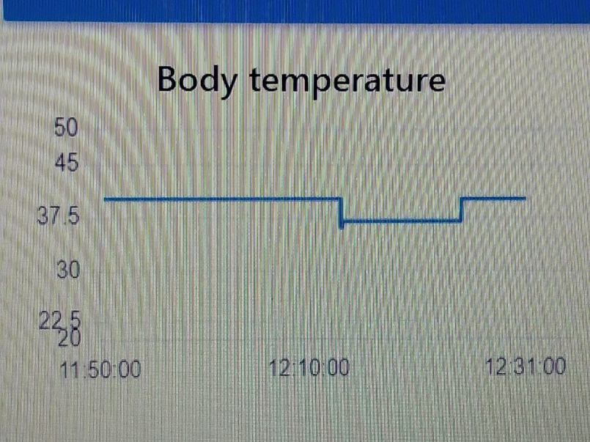

* Here, in this graph, we can see the temperature fluctuations.
* We used fast2sms webpage to send notifications to the mobiles.
* Then, we observed that when the temperature was kept as 40 degrees, we’ve got a notification which is shown below.

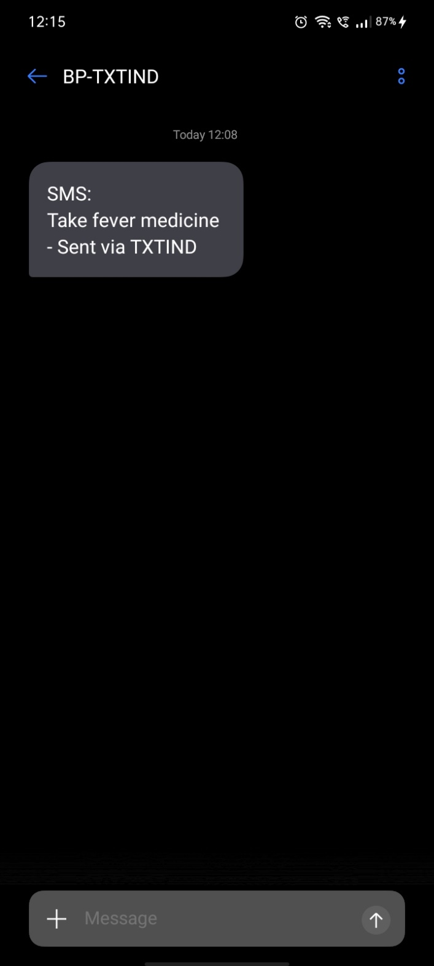

CONCLUSION:

We can use this to get notifications about our body temperature fluctuations.

THANK YOU